|  |  |  |  |  |  |  |
| --- | --- | --- | --- | --- | --- | --- |
| **Practicum Final Exam – Odd Semester Year 2021/2022** | | | | | | |
| **Subject** | | | **ISYS6169001 – Database Systems** | | |  |
| **Class** | **:** | **BI01 / BJ01** | | **Start Date** | **: 12 January 2022** |
| **Lecturer** | **:** | **D4625 - Trisna Febriana, S.Kom., M.M.S.I** | | **Start Time** | **: 07:20** |
| **End Date** | **: 12 January 2022** |
| **End Time** | **: 09:20** |

**PERATURAN UJIAN:**

*Exam Regulations:*

* Mahasiswa tidak diperbolehkan berdiskusi dan/atau bekerja sama dengan peserta ujian lainnya

*Student is not allowed to discuss and/or work together with other exam participants*

* Mahasiswa tidak diperbolehkan untuk membuka dan menyalin dari **BUKU** atau **CATATAN**, **VIDEO** dari pengajar (recording kelas, VBL, Youtube, dsb) dan **REFERENSI** lainnya

*Student isn't allowed to open and copy from any resources such as notes, videos (class recording, VBL, Youtube, etc) and other references*

* Mahasiswa tidak diperbolehkan membuka dan menyalin jawaban dari internet (google, stackoverflow, dsb)

*Student isn't allowed to open and copy answer from the internet (google, stackoverflow, etc)*

* Asisten **BERHAK** memberi nilai 0 **(NOL)** bagi peserta ujian yang melakukan segala bentuk kecurangan

*Assistant is able to give 0 (ZERO) score for exam participant who does any cheating actions*

* Kumpulkan jawaban tepat pada waktunya, apabila terlambat mengumpulkan maka jawaban tidak akan dikoreksi dan nilai mahasiswa adalah 0

*Submit the answer on time, if not, then the answer will not be checked, and the students will receive 0 (ZERO)*

* Bila Anda tidak membaca peraturan ini, maka Anda dianggap telah membaca dan menyetujuinya

*If you have missed to read these regulations, so you are considered to have read and agreed on it*

**SOFTWARE YANG DIGUNAKAN:**

*Software will be used:*

* SQL Server Developer 2019
* SQL Server Management Studio 18.9.1

**FILE YANG DIKUMPULKAN:**

*File must be collected:*

* SQL

**PERHATIAN!**

*Attention!*

* Bagi yang mengerjakan tidak sesuai dengan soal, maka akan diberikan nilai **NOL (0)**

*For those who do not work in accordance with the exam case will be marked as* ***ZERO (0)***

* Bagi yang mengerjakan tidak sesuai dengan software dan versi yang telah ditetapkan, maka akan tetap dikoreksi dengan software dan versi yang telah ditetapkan

*For those who do not work in accordance with the software and specific version will be corrected by the predefined software and version*

* Kompres semua jawaban yang akan diunggah. Pastikan format pengumpulan nama file dan ekstensi sesuai dengan format berikut: **[NIM]-[NAMA].zip**

*Compress all file that will be uploaded. Make sure the format for collecting file name and extension according to the following format:* ***[NIM]-[NAME].zip***

**Tabel Relasional**

*Relational Table*

**DZara**

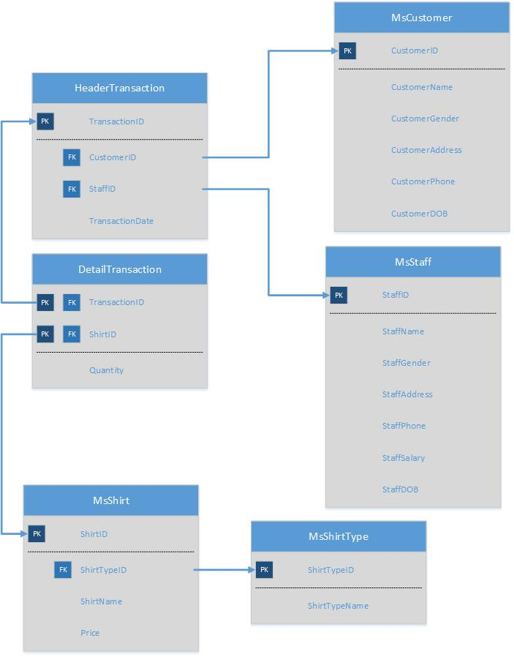

**Soal**

*Case*

1. Display **StaffName** and **StaffGender** for every staff whose last name is **‘Watson’**

(**like**)



1. Display **TransactionID**, **StaffName**, and **Day of Transaction** (obtained from the datename of TransactionDate) for every transaction that is handled by staff whose id is **‘ST003’**.

(**join, datename**)

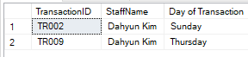

1. Display **Customer Name**, **Phone Number** (obtained by replacing ’0’ in front into ‘+62’ from CustomerPhone), and **Total Transaction** (obtained from the total number of transaction) for every every customer whose id is between ‘CU002’ and ‘CU004’.

**(stuff, between, count, join, groupby)**

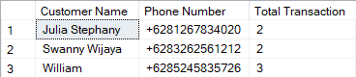

1. Display **Date** (obtained from **TransactionDate** in ‘Mon dd, yy’ format), **CustomerName**, **Total Price** (obtained from **total price of shirt**), and **Number of Shirt** **Type(s)** (obtained from **the total number of shirt**) for every transaction occurred in **February** and combine with **Date** (obtained from **TransactionDate** in ‘Mon dd, yy’ format), **CustomerName**, **Total Price** (obtained from **total price of shirt**), and **Number of Shirt** **Type(s)** (obtained from **the total number of shirt**) for every transaction occurred in **January.**

**(convert,union, sum, count, join, group by, month)**

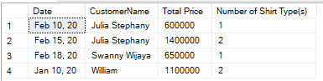

1. Display **StaffName**, **Salary** (obtained by adding 'Rp. 'in front of **StaffSalary**)for every transaction which quantity is **greater than 2** and handled by **Male.**

**(cast, in, join, like)**

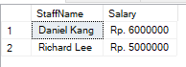

1. Display **ShirtID**, **ShirtName**, and **Price** (obtained by adding 'Rp. ' in front of **Price**) where the price is **greater than the average price** for every shir bought in **January** and the **name of the shirt contains 3 words.**

**(cast, alias subquery, avg, datepart, like)**

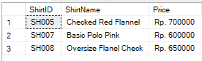

1. Create a **view** named ‘**CustomerView**’ to display **CustomerName**, **CustomerAddress** and **DOB** (obtained from **CustomerDOB** in ‘dd mon yyyy’ format) for every customer who born on **Wednesday.**

(**create view, datename, convert**)



1. Create a **view** named **‘ShirtView’** to display **Name** (obtained from **ShirtName), Total Price** (obtained from the **total** **price)** and **Type** (obtained from **ShirtTypeName**) for every shirt bought in **2021,** where the shirt name **contain three words** and the **total price is greater than 1200000.**

**(create view, sum, join, datepart, like, group by, having)**



1. Add a **column** named **StaffEmail** on **Staff** table with **varchar (50)** data type and add a **constraint** named ‘**CheckEmail’** to check the **StaffEmail** must **ends** **with** ‘@binus.ac.id’.

(**alter table, add constraint, like**)

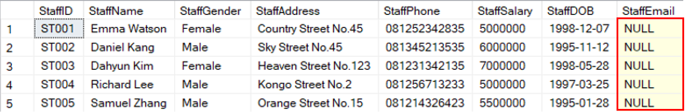

1. **Delete** data from **MsShirt table** for every shirt bought in 2020 and ShirtID between ‘SH007’ and ‘SH009’.

(**delete, join, datepart, between**)

**Before**:

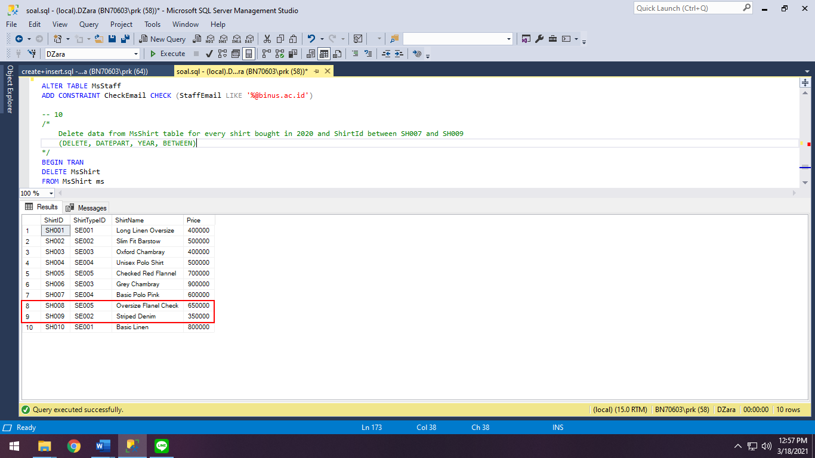

**After**:

